**R PROGRAMMING**

**CSE-437**



**AMITY SCHOOL OF ENGINEERING AND TECHNOLOGY**

**AMITY UNIVERSITY, UTTAR PRADESH**

**Submitted By: Drishti Arora**

**A2305220108**

**5CSE2-X**

**Q1.) View() command**

Used to view all the contents of a defined object.



**Output**

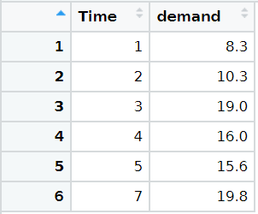

**nrow() command**

Used to return the number of rows of the matrix

**Output**

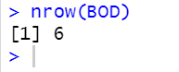

**Q2.) head() command**

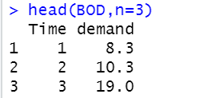

**Q3.)**

**(a)**

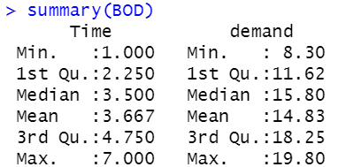

**(b)**

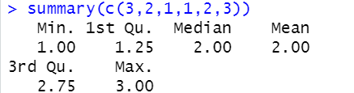

**(c)**



**(d)**



**(e)**



**(f)**



**(g)**



**Q4.)**

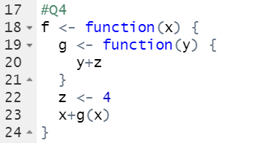

**Q5.)**

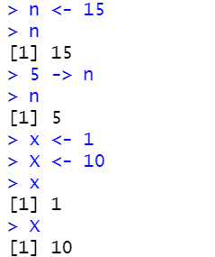

**Q6.)**

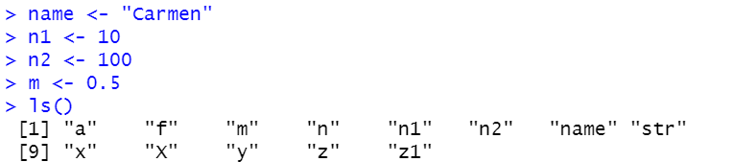

**Q7.)**





**Output**

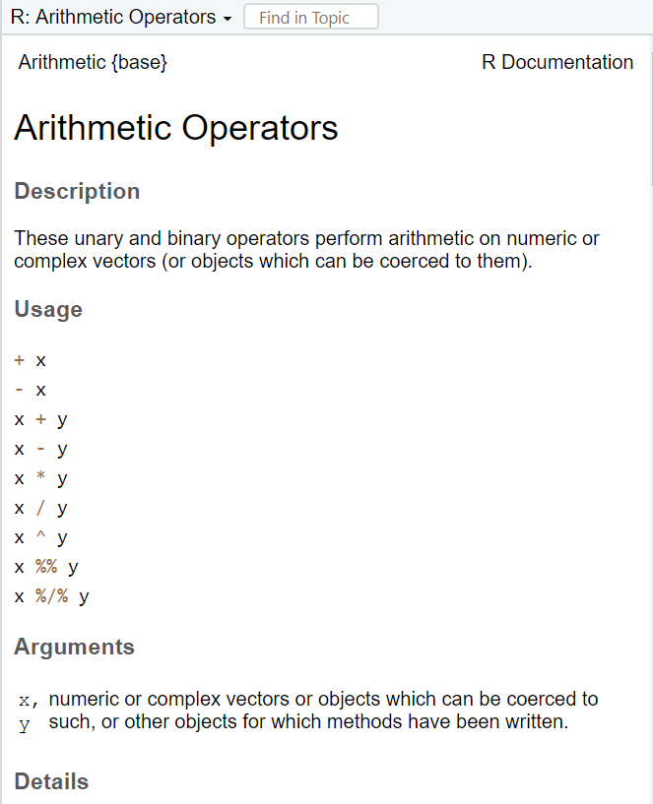

**Q8.)**

**Checking the class/ mode**

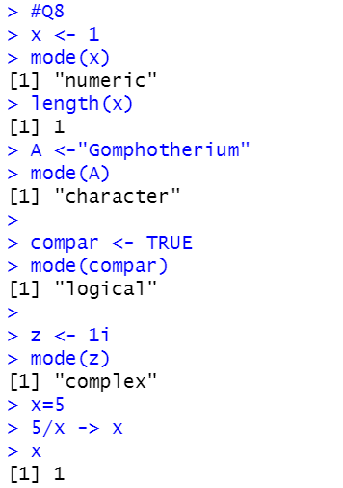

**Printing the series**

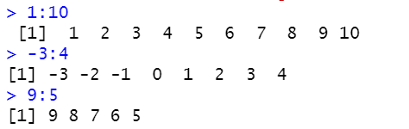

**Sequence Command**

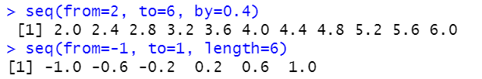

**Repetition Command**

